2023 NCF Scholarship Winners

Avery Natal Memorial Scholarship is to provide 5 graduating seniors pulled from Northshore High School, Pearl River High School, Salmen High School, Slidell High School, and Pope John Paul II High School attending in-state universities and vocational/technical colleges seeking a degree in either Psychology, Humanities, Social Studies, or related fields.
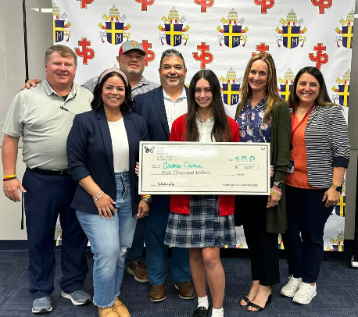
Ariana Caruso is a graduating senior from Pope John Paul II High School. Miss Caruso is the Executive Vice President of Student Council, a member of the National Honor Society, Student Ambassador, Co-captain of Dance Team, Retreat Team, Liturgy Team, and a Eucharistic Minister. Miss Caruso plans to attend the University of Louisiana at Lafayette to pursue a degree in Social Work.

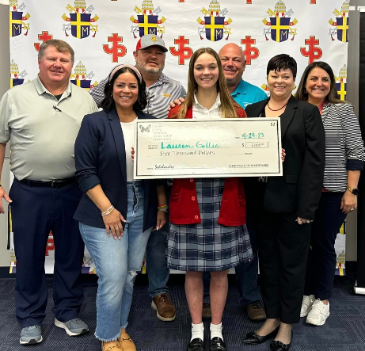
Lauren Gillio is a graduation senior from Pope John Paul II High School. Miss Gillio is on the Principal's Honor Roll, a member of the National Honors Society, Retreat Team, Vice President of HOSA, Media Club, History Club, Powerlifting and Volleyball teams and a Student Ambassador. Miss Gillio plans to attend Louisiana State University to pursue a career in Psychology.

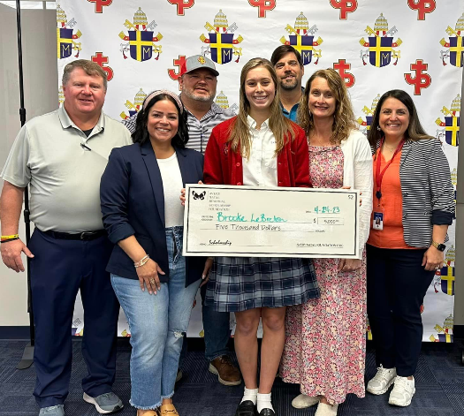
Brooke LeBreton is a graduating senior from Pope John Paul II High School. Miss LeBreton is Pope John Paul II High School Student of the Year and Archdiocese of NOLA Student of the Year and is on the Principal’s Honor Roll, she is the President of the Student Council, a member of the Jaguar Swim, Volleyball and Track and Field teams, National Honors Society, Retreat Team, Student Ambassador, and the Vice President Sanctity of Life Club. Miss LeBreton plans to attend Louisiana State University to pursue a career as a pediatrician.

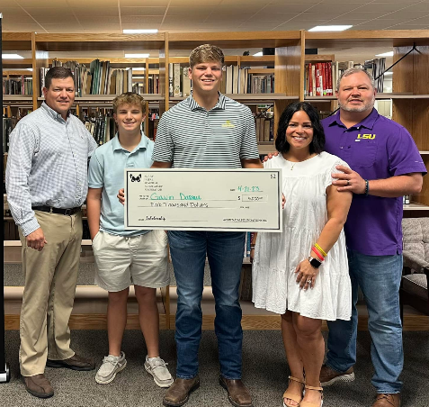
Gavin Dassau is a graduating senior from Slidell High School. Mr. Dassau was a Finalist for Student of the Year, Leader FCA, Treasurer of Next Generation Club and captain of both the football and soccer teams. Mr. Dassau plans to pursue a degree in nursing at Southeastern Louisiana University.

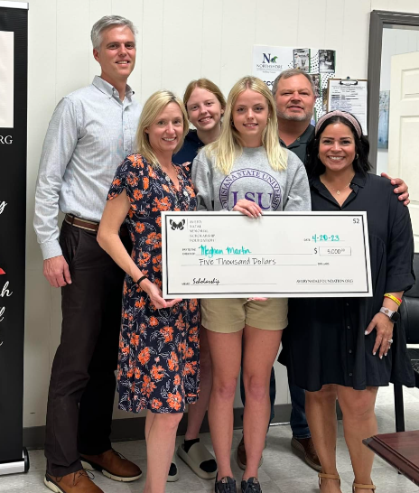

Meghan Martin is a graduating senior from Northshore High School. Miss Martin is the Treasurer of the Student Council, a member of the National Honors Society, BETA Club, Student Ambassador and is the captain of both the Track and Field and Cross-Country teams. Miss Martin plans to pursue a degree in the medical field at Louisiana State University.

Summers Legacy Opportunity Foundation Scholarship to support 3 graduating seniors residing in St. Tammany Parish who are facing challenges in their pursuit of higher education and planning to attend an out-of-state college/university.
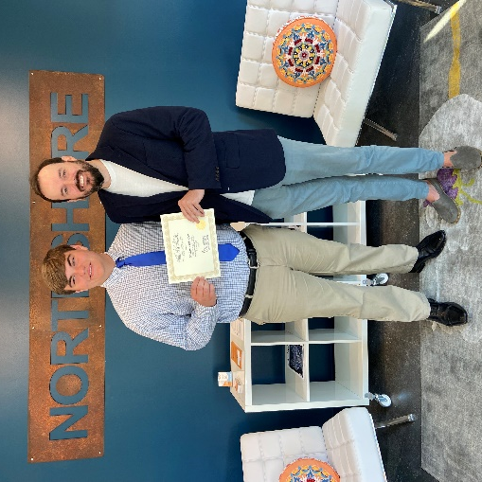
William Culpepper is graduating from Pope John Paul II High School. Mr. Culpepper was on the Principal’s Honor Roll, a member of the National Honor Society, Student Ambassador, and captain of the football team. He received the Honesty & Integrity Award and attended Louisiana Boys State Delegate Summer. Mr. Culpepper is facing financial hardships. He plans to attend Centenary College of Louisiana to pursue a degree in biology.

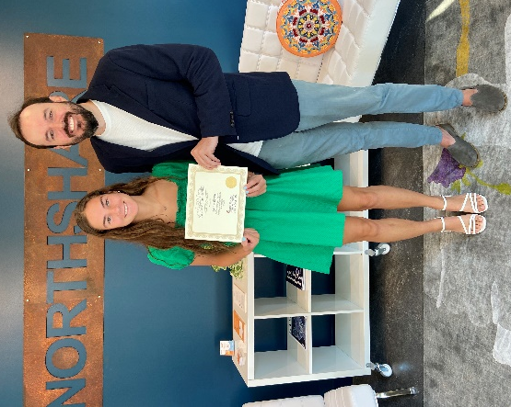
Grace Green is graduating from Northshore High School. She has obtained an Emergency Medical Responder Certificate. During her high school career, she was on the Honor Roll, a member of the BETA Club, Student Council, National Honor Society, Blue Crew, School Ambassador, and captain of the varsity soccer team. Miss Green is facing financial hardships. She plans to attend Louisiana State University to pursue a career in nursing.

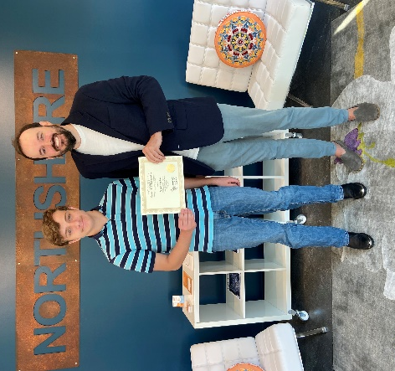

Brian Dickens is graduating from Slidell High School with ADHD and Autism. Mr. Dickens was a member of the JNROTC for all 4 years and a member of the Cub Scouts. He plans to attend Northshore Technical Community College.

Greg Zelden Scholarship to support graduating seniors and undergraduate students residing in St. Tammany, Tangipahoa and Washington Parishes attending a college/university seeking a career in Allied Health and/or Sports Medicine.
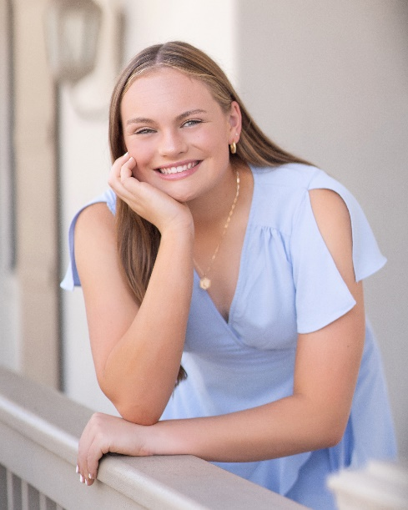
Logan Foster is a graduating senior from Archbishop Hannan High School. Miss Foster is on the Principal’s Honor Roll, President of the Spanish National Honor Society, Vice President of English National Honors Society, member of the Rho Kappa, Campus Ministry Core Team member, Eucharistic Minister, Student Ambassador, and Captain of Varsity Soccer team. Miss Foster plans to pursue a degree in Physical Therapy at the University of Kansas.

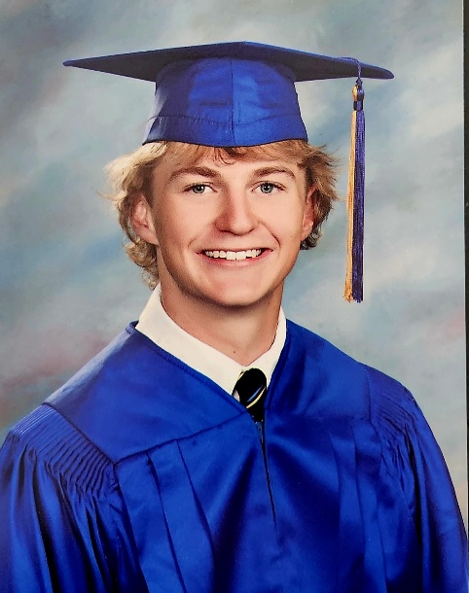

George “Drew” Bode is graduating from St. Paul’s School. Mr. Bode is a member of the National Honor Society, Key Club, an ordained Extraordinary Eucharist Minister, and Varsity Baseball team. Mr. Bode plans to attend Spring Hill College in the fall where he plans to concentrate on a medical management type occupation.

Donna Kahl Manetta Scholarship to support a graduating senior of Slidell High School who has demonstrated a record of high academic achievement and outstanding service to the school and the surrounding community.
Pat Brister Legacy Scholarship was established in 2021 in honor of the late Parish President Patricia Brister to support a female graduating senior of a St. Tammany Parish Public high school who has demonstrated a record of high academic achievement and outstanding service to the surrounding community.
The following recipient was awarded both of the above scholarships.
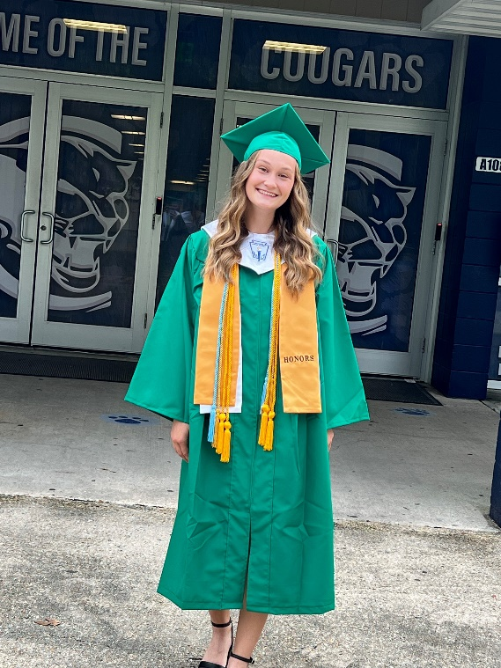

Mia Decker is a Student of the Year School Finalist, Vice President Mu Alpha Theta, a member of the Student Council, Beta Club, Captain of Soccer team and the Football first female in Louisiana academic All State. During her high school career, she has provided 664 service hours for various nonprofit organizations. Miss Decker plans to attend the University of North Florida to pursue a career as a Civil Engineer.

South Slidell Swimming Scholarship to support a high school senior(s) who participated in either the Salmen High School Swim Team or the Lakeside Gators Swim Team.
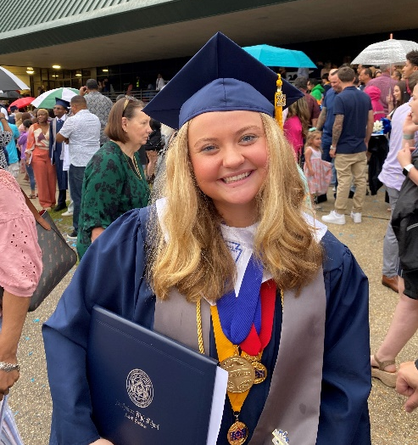
Gabrielle St. Pierre is a graduating senior from Northshore High School. Miss St. Pierre has been a member of the St. Tammany Lakeside Gators Swim Team for the past 14 years. She is the Student Council President, a member of the Panthers National Honors Society, Student Ambassadors, Future Farmers of America, BETA Club, Retreat Team, and Captain of the Swim team. Miss St. Pierre has plans to attend Carl R. Ice College of Engineering at Kansas State University.

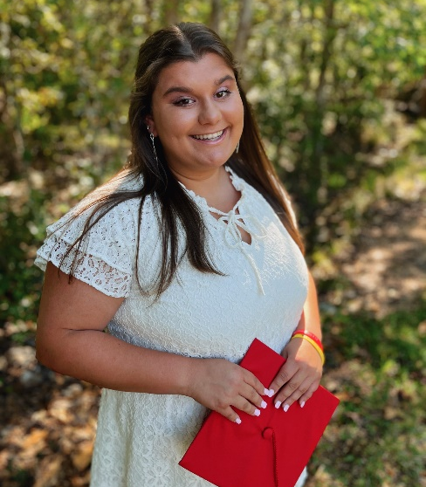

Alison Tullis is a graduating senior from Pope John Paul II High School. Miss Tullis has been a member of the St. Tammany Lakeside Gators Swim Team for the past 15 years. She is a member of the Jaguar’s National Honor Society, Student Council, Student Ambassador, Volleyball Team Captain, and Tennis team. Miss Tullis plans to attend Pearl River Community College.

Pat Brister Leadership Scholarship is to recognize the value of experiences outside traditional education to build leadership skills and create opportunities for professional and personal growth and impact. This scholarship is to provide a St. Tammany Parish woman the opportunity to engage in transformational training for personal and/or professional development to better enable them to impact their world.

Dionne Graham, Executive Director of Rainbow Childcare in Slidell, is this year’s recipient to pursue becoming a CFRE / Certified Fundraising Executive.

