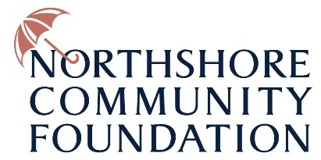

Hurricane Ida Nonprofit Grants
Physical Damage

The Northshore Community Foundation is offering grants to nonprofits that sustained damage to their physical structure from Hurricane Ida.

Qualifications: IRS sanctioned nonprofits that are located and operating in parishes that were declared disaster zones by the federal government, with a focus on the hardest hit areas of the Northshore.

The parishes within the declared disaster zone include St. Helena, St. Tammany, Tangipahoa, and Washington.

Amount: Maximum of $10,000
Application period: Open Now
Award Date: Ongoing

Nonprofits must fill out the form below to be considered for funding.

Name of nonprofit

Contact Name:

Title:

Contact Email

Contact Phone

Nonprofit’s parish location

Nonprofit Federal Tax Identification Number

Year Incorporated

2020 Total Revenues

Describe how you will use this grant funding / give a description of your damage.
(100 words maximum)

Grant amount requested

$

Project budget
Include amount covered by others (insurance, FEMA, etc.)
*no duplicative funding will be provided

Reporting terms:
A brief update on how the organization used the grant will be required and should be emailed to the Northshore Community Foundation. We want you to help us tell your story to donors, news media, etc.

Please include quotes and photos of appreciative clients or staff to help us tell your story. Before and After photos are encouraged.

Submission:
Please email completed application to info@northshorefoundation.org

