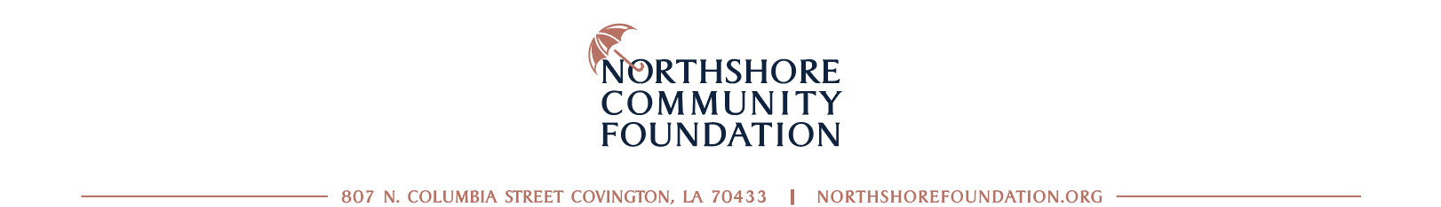

For Immediate Release Contact: Jeanne Martin, Communications Director, jmartin@northshorefoundation.org

Northshore Community Foundation Accepting Scholarship
Applications from Northshore Students for 2022
Online portal opens the door for students seeking scholarships to
easily apply for opportunities throughout the entire state

COVINGTON, LA, FEBRUARY 18, 2022 – Pathways for students to create a brighter future through educational scholarships can help with the many challenges that face our young people today. The Northshore Community Foundation has active and recurring scholarship funds which offer financial aid for higher-education and other instructional opportunities to students across the Northshore. The streamlined application portal makes it simple for applying students who will now have access to many available scholarships with varying criteria throughout the state, all from one portal which can be accessed at northshorefoundation.org/scholarships.

Applying for a 2022 scholarship through the Foundation portal is easy and involves three simple steps for interested students: 1) Visiting the site and answering prequalifying questions, 2) Setting up an account and filling out the application, 3) Using their account ID to go back and finish the application process or check on the status of their completed application. The portal automatically sends the application and uploaded substantiating documentation to any of the available scholarships the student has qualified for. Automated correspondence reminding the applicant to complete the process or letting them know their status will be sent to their supplied email address.

“The Foundation and our scholarship donors believe in investing in the young people of our region. We hope these opportunities afford our students the ability to thrive, inspire their peers and go out and make their dreams a reality,” said Susan Bonnett Bourgeois, CEO and President of the Northshore Community Foundation.

Scholarship areas of interest are not only merit-based, but include everything from leadership opportunities, creative arts and musical education, engineering-specific, region-specific, and out-of-state college opportunities, just to highlight a few.

Last year, the Northshore Community Foundation awarded scholarship grants in the amount of $219,681 to deserving Northshore students and since opening their doors 15 years ago has awarded more than $1,627,196 to students interested in furthering their higher learning achievements. Life-changing opportunities are just a few clicks away and the deadline for most applications is March 11, 2022. Visit NorthshoreFoundation.org to learn more.

###

The Northshore Community Foundation was started 15 years ago as a way to leverage generosity by uniting human and financial resources to enhance the quality of life on the Northshore. In that time, they have moved more than $60 million in philanthropic fuel through their doors.

