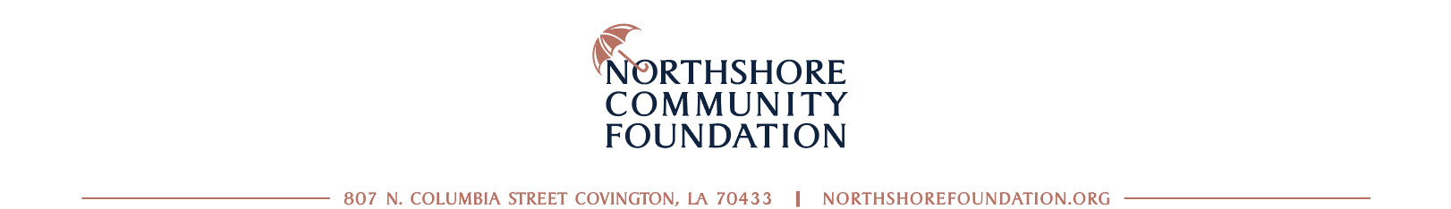

FOR IMMEDIATE RELEASE
CONTACT: Jeanne Martin, Communications Director, jmartin@northshorefoundation.org

Community Foundation Awards More Than $610,000 in
Newly-Awarded and Renewed Scholarships in 2022

COVINGTON, LA, JUNE 10, 2022 – The Northshore Community Foundation today announced they have recently awarded $611,000 in scholarships to local Northshore students. This year, seven new scholarships were added to eleven renewals for 2022. Since opening its doors 15 years ago, the Foundation has awarded more than $1.9 million to students working to further their education and expand their opportunities.

"Students and families everywhere struggle with the cost of higher education and the Northshore is no different,” said Susan Bonnett Bourgeois, CEO of the Northshore Community Foundation. "We are so proud to be able to help these hardworking students and so grateful to our fund donors who invest in the future of the children in our Region.”

As the leader in philanthropy on the Northshore, the Foundation facilitates these scholarships and countless other charitable efforts to help our region and our people thrive.

A list of all of the scholarships offered by the Foundation and the 2022 award recipients can be found at northshorefoundation.org/scholarships

###

The Northshore Community Foundation is celebrating 15 years of the generosity of its neighbors by uniting human and financial resources to enhance the quality of life on the Northshore. Leveraging more than $70 million in philanthropic fuel to date.

